**CURRENTS** :   
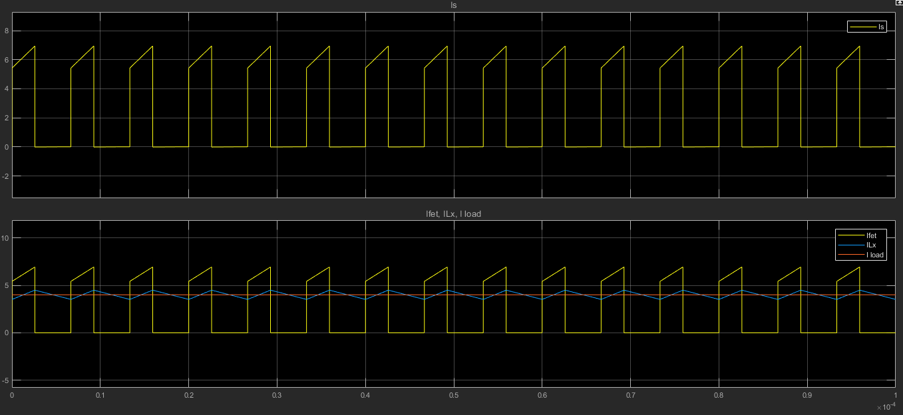

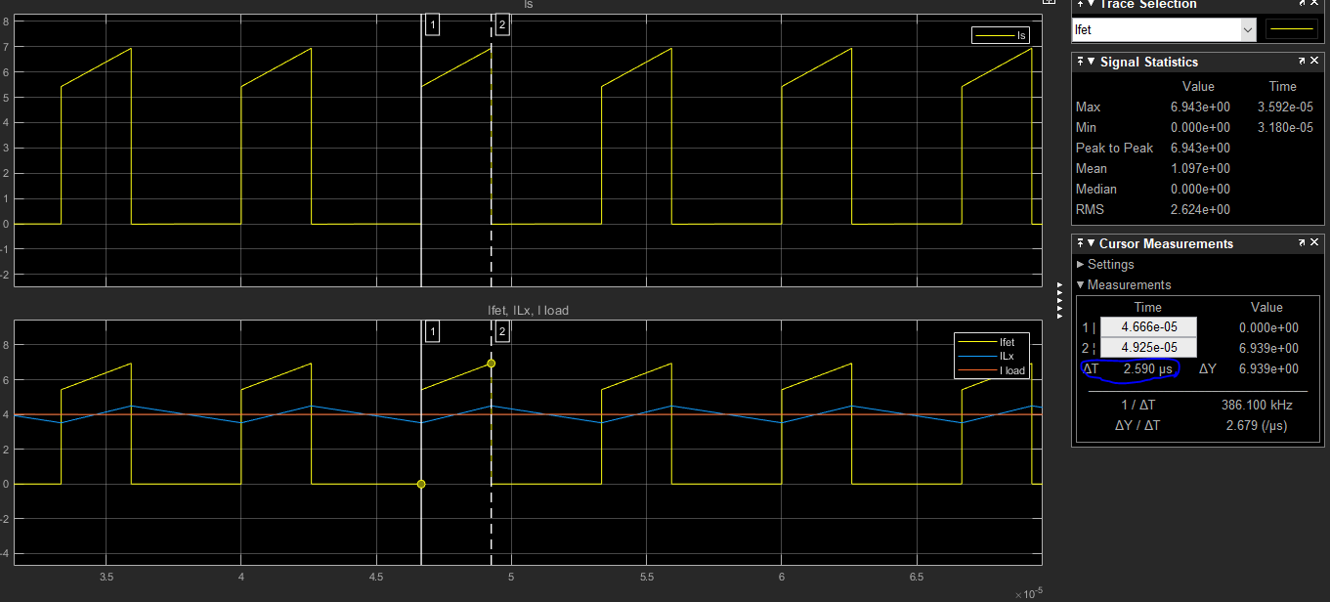

VOLTAGES

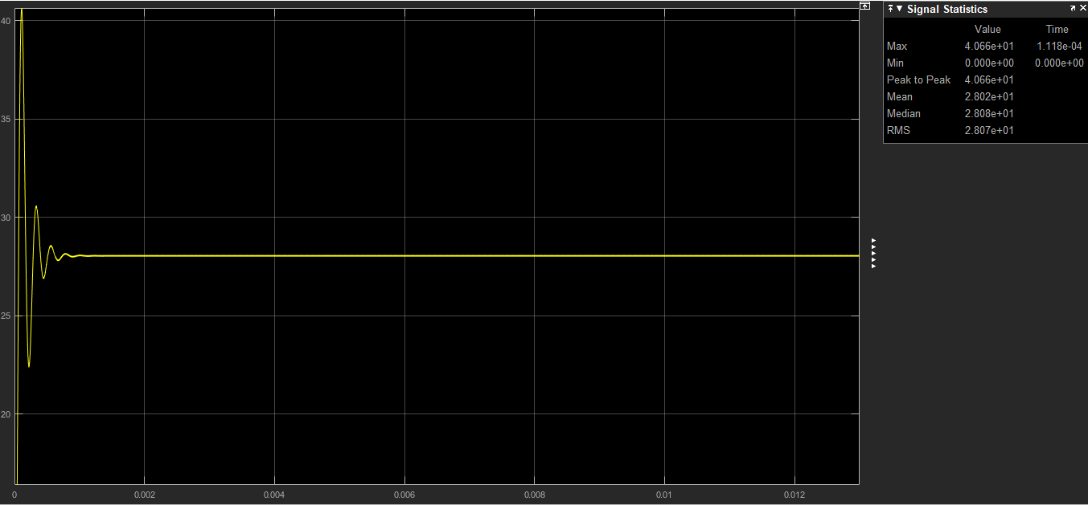

MOSFET DS VOLTAGE

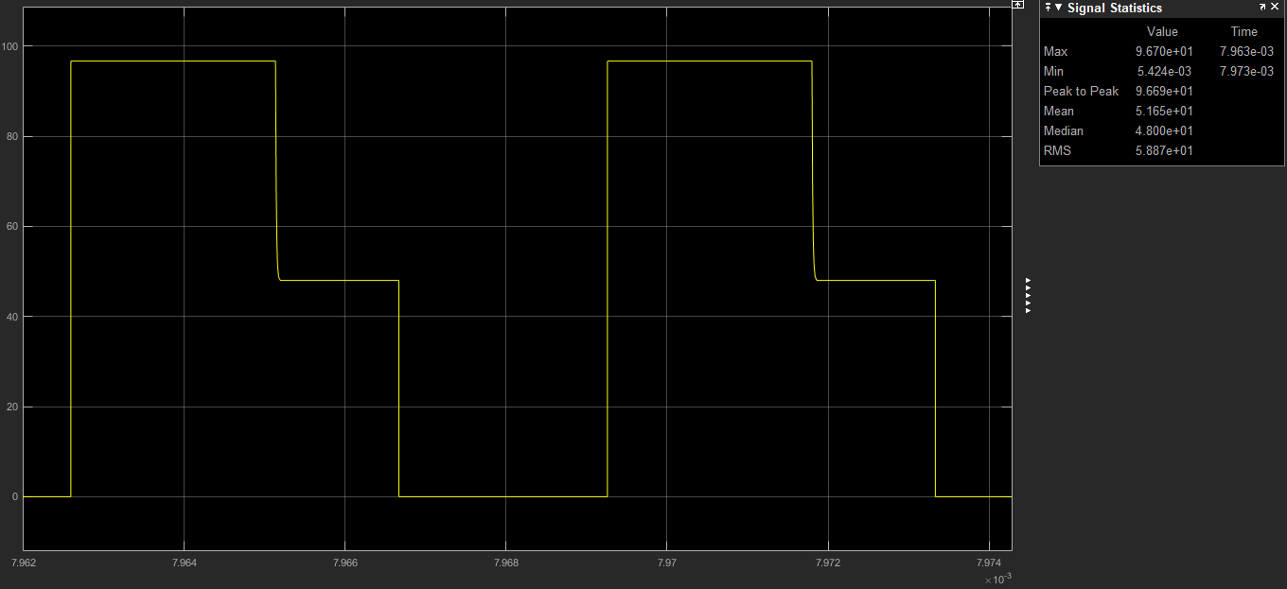

Min output current to operate in CCM, when Lo = 120u is 0.49A

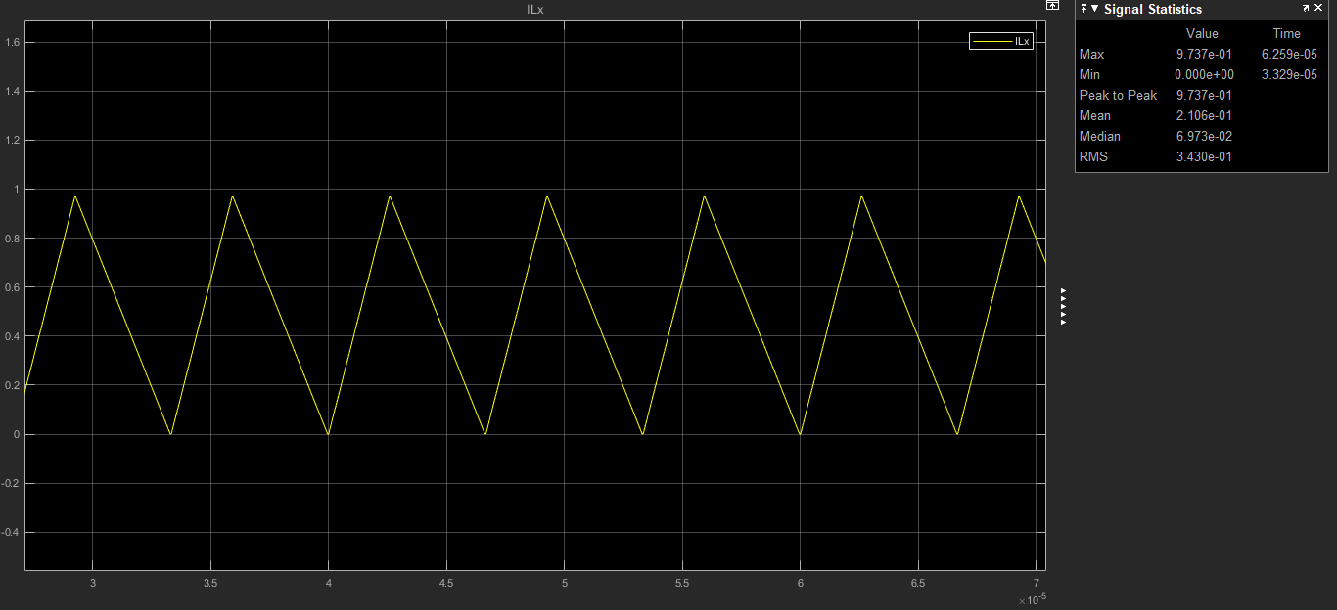

At boundary Io = $\frac{ΔILo}{2}$

output inductor current rises during on period. The min outpur inductor current ripple hence output current is occured at min ton.

$ΔILo$ = $\frac{VL}{Lo}$*ton

VL = $\frac{N2}{N1}$ Vinmax - Vo - Vdiode

where ton(min) = $\frac{Vo-Vdiode}{Vin max}$ $\frac{N1}{N2}$ $\frac{1}{fs}$** = 2,25 us.

where $\frac{N1}{N2}=0.65$

fs = 150kHz

Vinmax = 52.8 V

Vdiode = 0.7V

Vo = 28V

substuting ton value in above equation :

$ΔILo$ = [ $\frac{N2}{N1}$ Vinmax - Vo - Vdiode ] $\frac{tonmin}{Lo}$



$ΔILo$*

= 0.98 A

where Lo = 120uH

Io = $\frac{ΔILo}{2}$ = $\frac{0.98}{2}$ = 0.49 A which is minimum load current with 120uH output inductor to ensure CCM mode of operation.